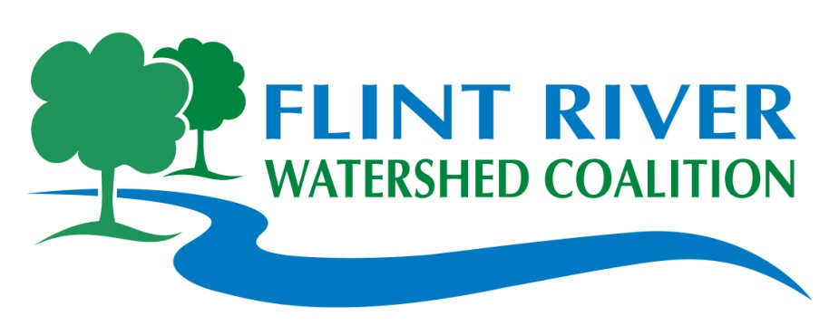

**Flint River & Community Cleanup**

**Saturday, May 21, 2011**

***Items provided:***

Free T-shirts, Lunch, Water, Gloves, Rakes, & Garbage Bags

***See Back of Flyer***

***for******Site Locations***

**Prescription drug Take Back**

Bring your old prescription drugs to our **Burton, Carriage Town, and Flushing** locations for safe and proper disposal.

Genesee County Prosecutor David Leyton, Genesee County Sheriff Robert Pickell, and Genesee County Community Mental Health departments have joined resources to make the Drug Take-back program possible

**Unacceptable Neighborhood Items:**

* Freon (Freezers/Refrigerators)

* Air Conditioners

* Auto Parts (Tires are OK)

* Building & Demolition items: Concrete, Dirt, Lumber, Drywall, Shingles, Windows, etc.

* Fluids, Gasoline, Oil, Paint, Transmission Fluids

*Trash mixed with Grass, Leaves, Brush

* Hazardous Wastes

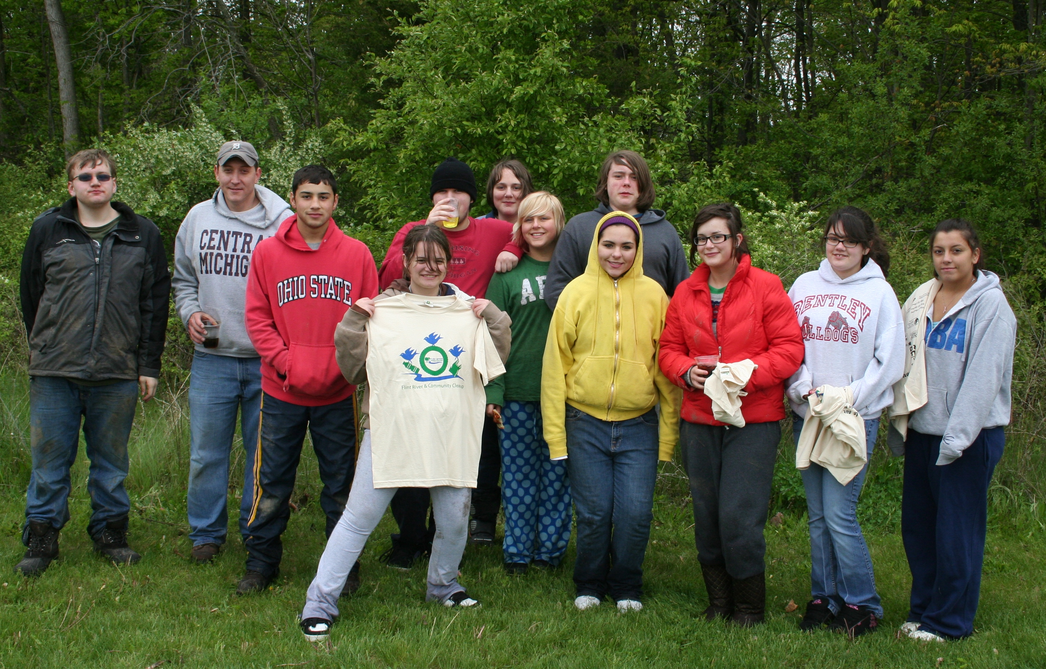

**9am – 12 noon**

**Come to Cleanup & Stay for Lunch!**

*See Back for Lunch Information*

Lu

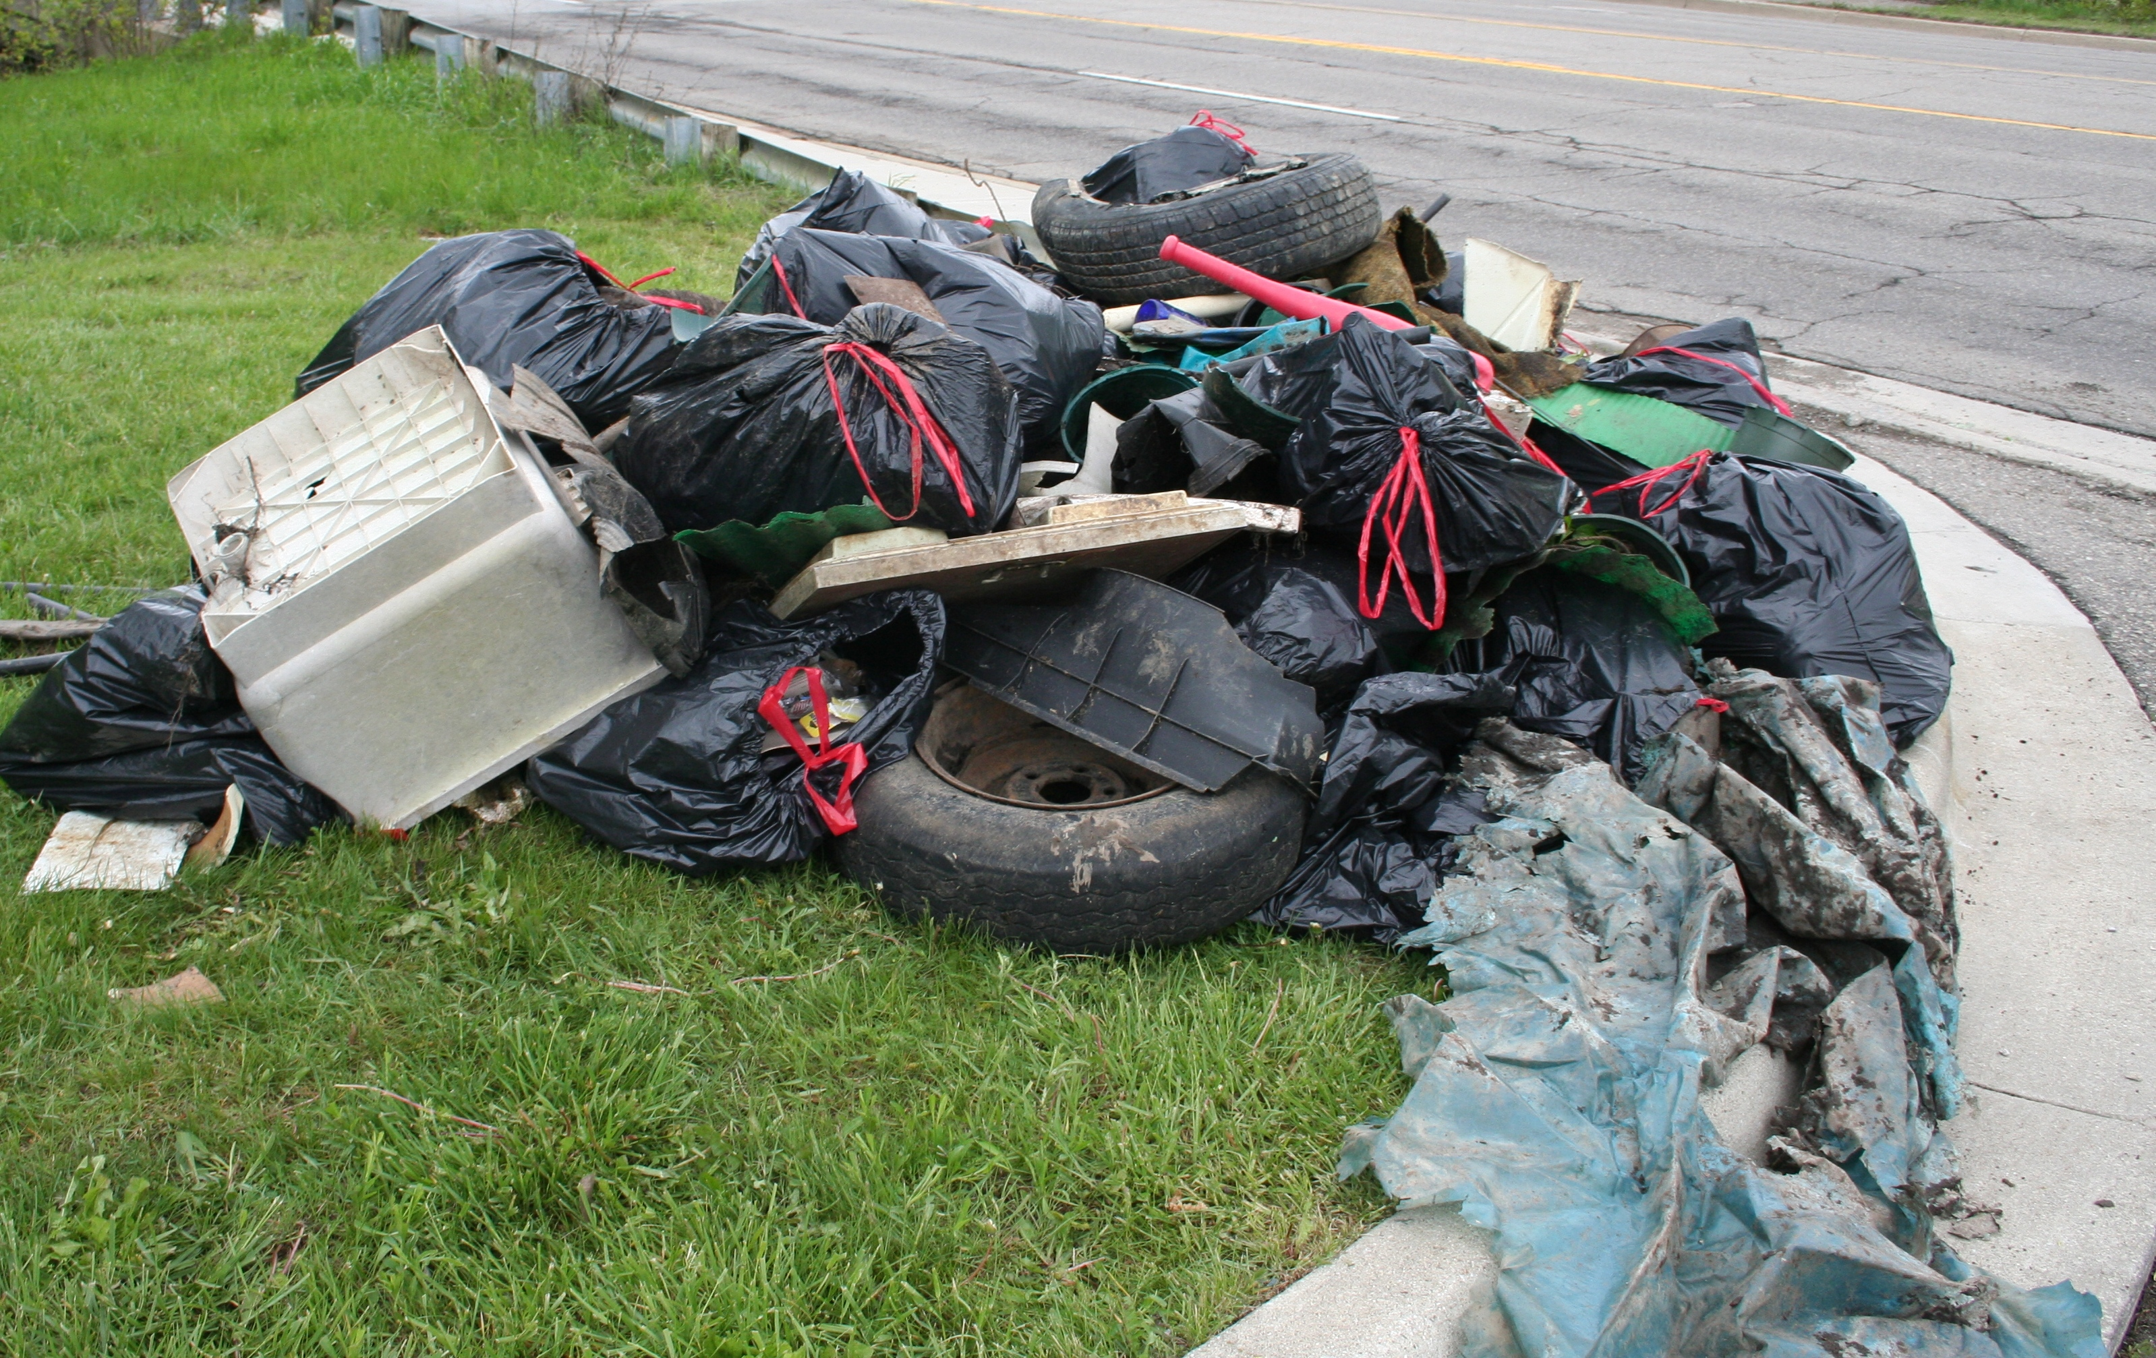

**Bring a Friend to Help Make this the Largest Cleanup Ever!**

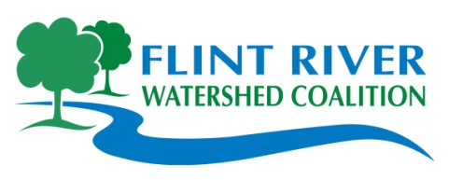

***Partnering to protect, preserve and improve the Flint River Watershed***

For Information **Call**: 810-767-6490 **Visit:** www.flintriver.org

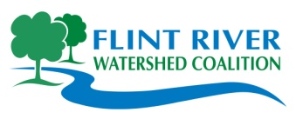**May 21st, 2011 Cleanup Site Locations**

**9:00 am to 12 noon. Lunch provided to Volunteers**

**Stay For Lunch!**

**Noon – 3 PM**

**Volunteer Celebration**

*(Your T-Shirt is your Ticket)*

**Downtown Flint**:

2nd Street between Saginaw and Harrison. In front of the Capitol Theater.

***Join us for food, great music, and celebration of a job well done.***

***Lunch provided by Carriage Town Historic Neighborhood Association, Ichthus Foundation, Spencer Agency, and Good Beans Café.***

***~ ~ ~***

***Lapeer Volunteer & Lunch Celebration*** *is held at the Wild Lapeer Event at Chatfield Schools*

***~ ~ ~***

***Ortonville Volunteer & Lunch Celebration*** *is held at the Old Mill*

***Flint River Watershed Coalition,***

***Partnering to***

***Protect, Preserve,***

***and Improve the***

***Flint River Watershed!***

**Contact the FRWC:**

400 N. Saginaw Street

Suite 233

Flint, MI 48502

810-767-6490

www.FlintRiver.org

**Genesee County:**

**Bendle Schools/Thread Lake, Burton: *Hosts:*** *Bendle High School, City of Burton*

**Location:** Burton: East Bristol Road, just West of S. Center Road. Park at Bendle Schools.

**Carriage Town Neighborhood: *Hosts:*** *Carriage Town Historic Neighborhood*

*Association, City of Flint*

**Location:** Downtown Flint: 301 Lyon Street. Park in lot near Durant-Dort Carriage Town.

**Clio City Park: *Hosts:*** *City of Clio*

**Location:** Clio: Park at the Clio Amphitheater and check in at Pavilion, M-57/Vienna Road to

The City of Clio.. Lunch at site.

**Downtown Flint: *Hosts:*** *Flint DDA, Ichthus Foundation, Spencer Agency*

**Location:** Capital Theater, 134 E. Second Street

**Flushing Riverview Park: *Hosts:*** *City of Flushing & Flushing High School*

**Location:** Flushing: 230 S. Cherry St., downtown Flushing (near the A&W Drive-In)

**Gilkey Creek/Pierce Park: *Hosts:*** *College Cultural Neighborhood Association, City of Flint,*

*Flint Schools*

**Location:** Flint: Pierce Park Golf Course, S. of Court St., W. of Dort Hwy. Gilkey Creek

from Dort Hwy. to Court St.

**Gilkey Creek/Wal-Mart, Burton: *Hosts:*** *Paul Remington*

**Location:** Wal-Mart parking lot, off of Court Street just West of Belsay Road

**Holloway Dam Canoe Access: *Hosts:*** *Steve & Carl Hester, Genesee Co. Parks & Rec.*

**Location:** Richfield Twp.: Carr Road at the Dam (between M15 & Henderson Roads)

**Katherine Price Unity Park: *Hosts:*** *MCC Gardening Association, City of Flint*

**Location:** Flint: off Saginaw St., N. of Pasadena between Ruth & Austin Ave. Park on Ruth

**Kearsley Park: *Hosts:*** *City of Flint Parks and Recreation, Mott Community College*

**Location:** Flint: Kearsley Park Blvd. N. of Rbt. T. Longway, 1/4 mile East of I-475

**McKinley Park: *Hosts:*** *Resource Genesee, Youth Leadership Genesee, City of Flint*

**Location:** Flint: McKinley Center at Orville St. & Peer Avenue

**Mott Park Neighborhood: *Hosts:*** *Mott Park Neighborhood Association, City of Flint*

**Location:** Flint: Park at Mott Park, Nolen Drive & Weller Street

**Vietnam Veterans Park: *Hosts:*** *Student Veterans of America, UM-Flint*

**Location:** Downtown Flint: James P. Cole Blvd., between Hamilton Ave. & Rbt. T. Longway Blvd.

**Riverbank Park: *Hosts:*** *Flint River Corridor Alliance*

**Location:** Downtown Flint: Sign in at Amphitheater at the Riverfront Residence Hall.

Parking available at the side parking lot on Garland and First Avenue

**Lapeer County:**

**Cramton Park: *Hosts:*** *Lapeer FRWC & Rotary, City of Lapeer*

**Location:** Near downtown Lapeer at S. Main Street, and W. Genesee St./Old M-21.

Contact Person: Peter McCreedy, 810-614-7594

**Oakland County:**

**Ortonville Kearsley Creek: *Hosts:*** *City of Ortonville*

**Location:** Registration & parking at the Old Mill at 486 Mill Street. Lunch at site.

Contact Person: Liz Waters 248-941-4152